EXPERIMENT 7:

SELECT WITH VARIOUS CLAUSE -GROUP BY,HAVING,ORDER BY.

**OUTPUTS:**

**1)**

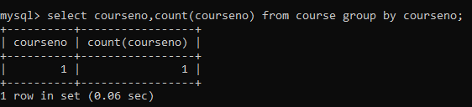

2)

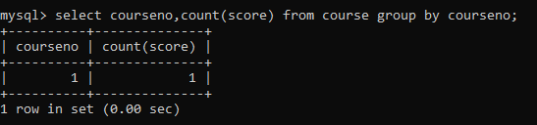

3)



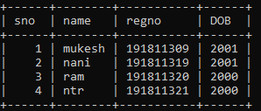

4)

